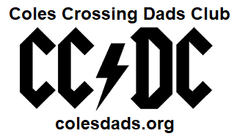
The Coles Crossing Dads Club (CC/DC) is currently seeking sponsors from the local community to assist in making our BBQ Cook-Off another great event for the residents of Coles Crossing.
The Fifth Annual Coles Crossing BBQ Cook-Off
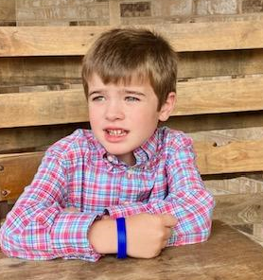
This year’s BBQ Cook-Off is scheduled for October 28, 2023, from 11am to 4pm at the Coles Crossing Lap Pool Parking Lot. We will be raising money to help support A Kid Again and our neighbor who spotlights the organization, Bennett Jefferson. Bennett is a young man from Coles that has been dealing with focal and generalized epilepsy since early 2021. His non-profit fosters hope, happiness and healing for children with life-threatening conditions by offering Adventures to help them feel like “A Kid Again.”
We are helping to raise money for Bennett and this charity to help bring more attention to the needs of these children across Texas to experience A Kid Again Adventures (more info available at akidagain.org).

Why Sponsor?
As a CC/DC BBQ Cook-Off Sponsor, you will receive the following:
- Ability to have an on-site marketing booth
- Website business logo with hyper-link on CC/DC website and Facebook page
- Business logo or name on Cook-Off T-shirts
- Business logo or name on the CC/DC Sponsor Board - displayed at the Cook-Off
- Complimentary participation in or ability to judge the Cook-Off, if desired
- “Thank you” mentions in the Coles’ Paper Boy magazine and in social postings from CC/DC
- Extended promotion of your support for CC/DC through the end of our operational year (ending June 2024)
About us
CC/DC was established in 2018 with a simple objective in mind – to improve the Coles Crossing Community through service, charity and fellowship. Through fund-raising events, such as the BBQ Cook-Off, CC/DC has awarded $22,000 in scholarships to Coles Crossing graduating seniors over the past five (5) years. We have grown from 13 members to our current 52 members. The BBQ Cook-Off broke even in year 1 (heavy rain) and we raised a net amount of $6,100 in year 4, including $4,500 from sponsors. Last year we had nearly 300 people come through our event and we expect this to grow year over year.
Additionally, CC/DC has provided small home repairs and services to families in need, coordinated trash pickup within our parks and walking trails, tended the Sampson Elementary School Garden and supported the Sampson PTO and Coles Crossing Crocs swim team through sponsorship and volunteer hours.

Sponsorship FAQs
Who is my audience?
The Coles Crossing neighborhood includes approximately 2,400 homes with residents working in all types of career fields.

Where do I send my sponsorship?
Mike Crafton and Aaron Cope are your contacts for CC/DC sponsorship.
michael.crafton@gmail.com aaroncope@gmail.com
(619) 985-2882 (202) 412-8276

What types of payments does CC/DC accept?
CC/DC accepts checks, cash, and Venmo at @ColesDads-Club.

When is the deadline for sponsorship?
The deadline for sponsorship is Saturday, October 14, 2023.

Please provide the following information to CC/DC:

Company Name:
Company Mailing Address:
Company Website (Please include an electronic copy of your business logo for the Cook-Off Sponsor
Board and CC/DC website):
Company Contact name for CC/DC Communication:
Phone: Email:
Indicate size of complimentary t-shirt, if desired:

CC/DC is not a 501(c)(3) organization at this time.
For questions regarding CC/DC please contact: info@colesdads.org or Rich Henderson at (281)928-1082.

